**Summary of readings**

**Week 1 (11 & 13 AUG)**

**Sociology as a way of seeing (TES)**

*Berger, Peter L and Kellner, Hansfried (1981) 'Sociology as a way of seeing', in Sociology Reinterpreted: An Essay on Method and Vocation. NY: Anchor Press.*

Manifest and Latent functions

* Robert Merton coined this two terms to show that the world is not that it appears to be.
* **Manifest- "officially defined" purpose of a particular social institution or social arrangement**
* **Latent - "underlying"/ "unperceived"/"unconscious"**
* Example of education: Manifest function is to transmit knowledge while the 'latent' function to erect and maintain social class

*Mills, C. Wright (1997 [1959]) ‘The Promise’ (from The Sociological Imagination) in Henslin, James M. (ed) Down to Earth Sociology: Introductory Readings . 9th edn. NY : Free Press.*

* Sociological imagination is seeing how the unique historical circumstances of a particular society affects people and at the same time how people affect history.
* **Trouble is a private matter**; and occurs within the character of the individual and within the range of his immediate relations with the others. (they have to do with his self and with those limited areas of social life of which he is directly and personally aware)
* **Issue is a public matter**; have to do with matters that transcend these local environment of the individual and the range of his inner life. (larger structure of social life and historical life)

**Week 2 (18 & 20 AUG)**

**Doing Sociology (TES)**

*Bilton, Tony (et al.) (2002) ‘Studying society today’ in Introductory Sociology. 4th edn. Basingstoke : Palgrave.*

**Social institutions**: Social practices that are regularly and continuously repeated, legitimised and maintained by social norms

**Social movement:** a broad alliance of people with common interests or goals acting collectively to promote or prevent some form of social change

**Durkheim**

* Living in the modern society requires us to put trust in others.
* **Organic solidarity**: the identification of others through differences, in that individuals had very different roles and economic functions and needed each other to fulfil all their needs. No individual or section of individuals can function effectively without engaging in interaction with others.
* **Anomie**: situation in the society which the sense of collective identity and shared interests and values are in decline and individuals acted independently of commonly recognised norms of behaviour or social standards.

Marx

* Primary motivation for productive activities was the pursuit of profit.
* Class analysis in his sociological theories.
* Power as unequally distributed across societies and economic power forms the basis for other form of power.

**Week 3 (25 & 27 AUG)**

**Power, Politics and the State (TES)**

Allen, John (2004) ‘Power: Its Institutional Guises (And Disguises)’ in Gordon Hughes and Ross Fergusson, eds., *Ordering Lives: Family, Work and Welfare*. 2nd Edition. London: Routledge. pp7-43.

Authority may be experienced in two ways

* Someone in authority by virtue of their position in a particular institution or as an authority in some particular field of expertise

|  |  |
| --- | --- |
| **Term** | **Definition** |
| Coercion | To compel by force or its threatened use |
| Manipulation | To conceal the real intent behind an action in order to gain an advantage |
| Persuasion | To appeal or suggest to others the merits of an particular action, whilst accepting the possibility of refusal |
| Authority | Something that is claimed, and once recognised, serves as the basis by which others willingly comply |
| Domination | To impose upon or constrain the free choice of others despite possible resistance |
| Bureaucratic power | A form of movement, rule-bound power based upon a clearly defined hierarchy of office |
| Provocation | To incite or induce a certain course of action |

Giddens

* We no longer live in a period where trust in an authority is easily given or where faith in the experts is willing conceded.
* Public has learnt to be sceptical about claims.
* We withdraw our faith or belief easily.

Weber

* Modern bureaucratic authority: divorced from personal ties and influence
* While officials exercise power from the top-down approach, it is done within the strict limits laid by bureaucracy.
* Only those on the very top are capable of changing the structure and system.

|  |  |
| --- | --- |
| Max Weber | Micheal Foucault |
| Power in a direct affair | Power is an indirect affair |
| Capacity possessed by certain institutions, individuals and groups who use it directly to secure there interests | Something which is exercised behind our back and is not conscious |
| Power is straightforward and clear; either you have it or you don't. | Power isn't in anyone's hands. It is not obvious but rather something that constrains how we act |
| Power in a institutional setting is a top-down, hierarchy affair. | Power circulates through organisational practices and acts like a 'grid', provoking and inciting certain actions and denying others |
| Obedience is secured by those in authority and only legitimate authority will others be compliance. | Compliance is not straightforward and depends on how deep the individuals internalise what is being laid out as obvious. |
| Domination by authority involves the imposition of rule-bound constrains on the conduct of others | Domination works on the basis of self-constraint rather than external constraint. People governs themselves |
| Bureaucratic power comes in clearly-defined lines of authority and delegation | Power is provocative, it is brought on people's actions and closing down rather than opening possibilities. |

Giddens, Anthony (1986[1982]) 'The modern state', in*Sociology: A Brief But Critical Introduction.* 2nd edn. Basingstoke , Hampshire: Macmillan Education.

State provides the legal framework which guarantees the protection of economic contracts and generally oversees the interests of the community.

Expanding role of the state as it not only take cares of the economical aspects but also the social aspects of people.

Marx

* State is in direct instrument of class rule, controlled in an immediate way by the capitalist class
* Class nature of the state consists in the fact that state officialdom protects the overall continuity of capitalism production.
* Economists fails to recognise the class nature of the state. State is involved in the sustaining of the protected interests of the dominant class against those of other classes in society.

Durkheim

* State helps eradicate class division and inequalities.

Weber

* The advance of bureaucracy is linked to the expansion of capitalism.
* Bureaucracy promotes the centralisation of power in the hands of the minority.

 Offe

* 'commodification' and 'decommodification' of social relationships in the marketplace
* Labour or socialist parties tend to create or pursue policies that expand non-commodified relationships, such as free healthcare for everyone, and more chance for education
* While conservative parties who usually draw power from the upper or middle class are likely to preserve commodified relations

|  |  |  |
| --- | --- | --- |
| No | View | Opposite View |
| 1 | **Marx**: dominant class is a unitary social formation and this class manipulates the state at will | **Pluralist**: no homogenous 'ruling class' in the western society as there is a diversity sets/pluralities of elites, each having limited power to influence government policy |
| 2 | **Poulantzas:** state has relative "autonomy" from the capitalism class. State may initiate policies counter to the short-term interest of certain capitalist groupings, in order to defend the long-term perpetuating system as a whole. | **Karl Kautsky**: "the ruling class does not rule" |

**Week 4 (1 & 3 SEP)  [Term Assignment Released]**

**Culture and Socialisation (KL)**

Goffman, Erving (1959[2005]) ‘The Presentation of Self in Everyday Life.’ in James M. Henslin (ed), *Down to Earth Sociology: Introductory Readings.*13th edn. NY: Free Press, 117-128.

First impression often involves the enforcement of "class" which is often irreversible.

He believed that when an individual comes in contact with other people, that individual will attempt to control or guide the impression that others might make of him by changing or fixing his or her setting, appearance and manner. At the same time, the person the individual is interacting with is trying to form and obtain information about the individual

Observers can get clues from the individual's conduct and appearance which allow them to apply their previous experience with individuals roughly similar to the one before them or more importantly to apply untested stereotypes to him. - Thus the more people you meet, the more likely that you judge the person based on this circumstances.

Traditional communication- the expression one gives; which involves verbal symbols or their substitutes which he uses admittedly and solely to convey the info he and others are known to attach to these symbols.

Individual can intentionally convey misinformation by means of both of these types of communication, the first involving deceit (expression one gives) and the second feigning (the expression one gives off).

Individuals appear before others he will have motives for trying to control the impression they receive of the situation.

**Impression management** is a goal-directed conscious or subconscious process in which people attempt to [influence](http://en.wikipedia.org/wiki/Social_influence) the [perceptions](http://en.wikipedia.org/wiki/Perception) of other people about a person, object or event; they do so by regulating and controlling information in social interaction

Miner, Horace (1956) ‘Body Rituals among the Nacirema.’ *American Anthropologist* 58(3): 503-507.

Linton, Ralph (1937[2002]) ‘One Hundred Percent American.’ in Philip R. DeVita and James D. Armstrong. (eds) *Distant Mirrors: America as a foreign culture.*Belmont, CA: Wadsworth/Thomson Learning, 1-3.

**Week 5 (8 & 10 SEP)**

**Family (KL)**

Howard, Michael C. (2011) ‘Marriage and Families’ (Chapter 4) in *Transnationalism and Society: An introduction*, Michael C. Howard. Jefferson, N.C.: McFarland & Co.

Brides often have this typical attitude that as long as they can go overseas (America), they can marry anybody, which is due to the strong  force of improving their own status through working and making money.

Male migrants often marry within the same ethnic group or from their own country as they want to maintain their own identity and connect to their country of origin.

Example: Korean man in Hawaii send for picture brides not necessarily because they could not find other women to marry- although it is true for many cases but mainly because they want to marry a Korean women.

Whether the migrants is able to make a good living plays a huge role in determining the success of the marriage or engagement.

Vietnamese women- brides are not necessarily poor, nor do they only marry men above them on the socioeconomic ladder. Due to imbalance in gender ratio in Vietnam (more girls than guys), women has become more difficult to find husbands.

Inter-ethic marriages- often involves foreign soldiers who are stationed for a long time and marrying local women.

**Week 6 (15 & 17 SEP)**

**Race and Ethnicity (KL)**

Purushotam, Nirmala (1998) ‘Disciplining Difference: Race in Singapore.’ in Joel S. Kahn (ed) *Southeast Asian Identities: Culture and the politics of Representation in Indonesia, Malaysia, Singapore, and Thailand.* Singapore: ISEAS, 51-94.

* Concept of race in Singapore is suppose to be straightforward, which is perceived to come from the biological differences between people
* Race is often mixed up with the nationality in colonial history
* Broaden the use of "Malay"
* Chinese "tribes" is used to differentiate trades.
* Education often instils that we are ethnically different, and the differences are imposed upon us even though as a child we do not recognise such differences.
* Perception from British is that Malays were laid back or lazy
* Indian are "docile"

**Week 7 (29 Sep & 1 OCT)**

**Gender and Sexuality (KL)**

 West, Candace and Don H. Zimmerman (2002) ‘Doing Gender.’ in Stevi Jackson and Sue Scott (eds), *Gender: A Sociological Reader* . Lond & NY: Routledge, 42-47.

* Gender is a learnt behaviour
* Its is not as straightforward as it seems, as it is complex due to the implementation of "gender-behaviour to the situation"
* Virtually any type of activity can be gender differentiated.
* Society views gender as a black and white issue; either you are male or female.
* Sex- application of socially agreed upon biological criteria for classifying persons as male or females.
* Gender- is the activity of managing situated conduct in light of normative conceptions of attitudes and activities appropriate for one's sex category.
* Presumption that essential criteria of the sex exist when we do gender or sex classification (Kessler and Mckenna)

Agnes is born a boy; raised as a boy but took female pills in order to suppress puberty and have female characteristics since 12. Mind: Female Behaviour: Female? Body: Male

Purushotam, Nirmala (1998) ‘Between compliance and resistance: Women and the middle-class way of life in Singapore.’ in Krishna Sen and Maila Stivens (eds), *Gender and Power in Affluent Asia*. Lond & NY: Routledge, 127-166.

* Dual gender is enforced in Singapore
* Singapore government seems to support patriarchal society and traditional families.  Through its policies that do not favour single moms.

**Week 8 (8 OCT) Class and Stratification (TES)**

Social class:   Elite (upper class)

Upper Middle Class

Middle Class

Lower Middle Class

Poor

If u describe social class, as frame; prestige and honour. Class is a feeling; a subjective category.

Stratification: Weber and Marx

**Marx: Capital = Means of production**

Bourgeoisie and Proletariat

* Bourgeoisie are owners of the means of production; example the land and factory
* Can be business, ownership of knowledge.
* Proletariat are the working class with labour (Wright says that labour is power enough)
* Restriction of wages to maximise profit.
* Alienation of the working class; the lack of power to do anything (marginalised is like the segregation) **the lack of ownership to your own production; thus the worker feels unjust and unrecognised.**
* Resistance- Struggle. Ideally leads to a classless society.

Class consciousness = doesn't matter where u are, but they should come together to fight. For the bourgeoisie is the maintenance of class.

Classless society= Marx is not clear on how to carry out classless society leading to many twisted forms.

"False consciousness"- the thinking among the working class that they are working for the greater good and thus should continue working. The use of super structures (e.g. Laws, schools and religion)

**Weber**

* Class is based on social differences rather than only economic power
* Status, political parties and class are examples of stratification.
* Status- social/cultural/symbolic examples of school. Honour and popularity in the society.
* Political parties-political power.
* Upper class, white collar workers, petite bourgeoisies, manual working class
* Weber feels that the degree of party organisation does not determine class consciousness your solidarity; only can obtain prestige and honour. Marx believe that class consciousness is developed due to degree to party organisation.
* Life chances- for upward mobility; class is not as rigid.
* Microstructures; while Marxist is more macrostructures.

Middle class is a very strong political group that is flexible. Can change the whole political movements. Highly developed countries have consumerism who unites them. The elite desire to own the upper class commodities. Caste system is a closed stratification; which is inflexible because you are born to it.

Democracy- race, class, gender, age and religion separates the people and restricts upward mobility.

Newman, Katherine S. (1988) 'American nightmares', in *Falling From Grace: The Experience of Downward Mobility in the American Middle Class.* NY: Free Press.

* downwardly mobile- which has little attention from policy makers, scholars to the public as it is lowly visible
* Downward mobility is not simply an episodic or unusual phenomenon in America, but a regular function of the economic landscape.
* Little people can do to prevent themselves from sliding
* Often just above the poverty line but below the affluence level that they were affording.
* Against the mind-set that if we work hard, we will be able to succeed as they feel frustrated about their situation which is often regarded as the same as poverty.
* Remains unacknowledged as it doesn't fit into America's culture
* Confusion by people who are in this category as they suddenly are regarded as "working poor or unemployed".
* It is hard for them to abandon the glorified old self and embrace their problems.
* Creates a common sense of failure, loss of control, and social disorientation.
* Divorce is a primary source of downward mobility; especially for women who were housewives and are pushed into jobs that pays well. This is due to the gender roles in the society.
* Impact of mobility depends on contacts and the type of job the person was having. The richer he was, the more likely the fall is cushioned.

Mooney, Gerry (2008), 'Explaining poverty, social exclusion, and inequality: towards a structural approach' in Tess Ridge and Sharon wright (eds.) *Understanding Inequality, Poverty and Wealth:  Policies and Prospects.* Bristol, UK: Policy Press.

* Basic structural explanation seeks to locate the analysis and explanation of issues from poverty and social exclusions through to inequality, wealth and power in the context of wider social relations that structure society.
* Social factors and roles determine what Max Weber say is 'life chances', the interplay of personal and social factors that shape the opportunities and life that individuals will experience
* For Richard Wilkinson, the degree of inequality in the social environment is reflected in society in different ways, including the level of trust, involvement in community life, morbidity and mortality, in anti-social behaviour, drugs and alcohol addiction, anxiety, stress, depression, insecurity and so on. He argues that the 'quality of social relations in societies is related to the scale of income inequality- how big the gap is between rich and poor'. Problems which are often regarded as personal, example - depression and stress, are attributed to the unequal relations and structures of the society.
* Inequality matters in many direct and indirect ways and work to shape the relations of every day interactions and social relations which we are located.
* Class is the primary determinant of social life and helps explain social patterns such as voting, personality traits and lifestyle. UK's society is largely regarded as de-classed.
* Marxists do not isolate people experiencing poverty from the rest of the society but sees it as part of a relationship of inequality, economically, materially and politically. The production and accumulation of profit, of wealth, is also simultaneously the production and accumulation of poverty, wants and misery.
* Tony Novak " Poverty is not simply about the way that society's resources are distributed, but also about the way these resources are produced' - Marxist
* People experiencing poverty are constructed as ' a problem' to be managed and controlled, while the wealth and the rich is regarded as normal.
* Jones and Novak refers to as the 'abuse of the poor' which the construction of people experiencing poverty as an underclass or dysfunctional group.

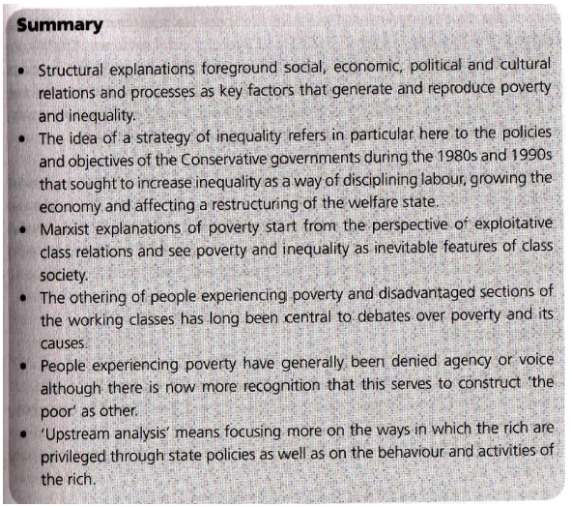

**Week 10 (20 & 22 OCT)**

**Religion (TES)**

Tutorial discussion: Does it promote social integration?

* Do not (do not agree with Durkheim) as there is social integration within the same domination but not between the various religious groups.
* Sources of social conflict among religion: mainstream religion side-lining the minority religion.
* National religion: majority practices the religion, while the state: legal framework; civic religion: the government being used in the public sphere, the way which the religion is being used in practices.
* Religion and State finds a compromise.
* Constitution of USA has the mention of god. Religion is needed in politics.
* USA is imposing American liberalism on Iran.

Does modernity spell the demise of religion?

* Live religion: personal faith and belief; making a choice for yourself and choosing what suits me.
* Organised religion:  imposed sanctions on those who do not follow rules.
* Religion is not static and it is changing; migration of people and globalisation leads to the spread of religion.

Stark, Rodney (1997) 'Bringing theory back in' in Young, Lawrence A, ed., *Rational Choice Theory and Religion.* NY: Routledge.

**Durkheim**

* "there is no church of magic"
* Magic and religion are different; magic does not waste its time in pure speculation.
* Religion has always disfavour magic rituals/rites.

Religion can be viewed economically, each religion caters to the special needs and tastes of specific market segments.

Compensator in which your work is compensating

Stark, Rodney (2001) ‘Religion’, in *Sociology*. 8th edn. Belmont, CA: Thomson/Wadsworth.

Religious institutions becomes worldly, a process called secularisation.

Religion involves questions about the ultimate meaning such as Does life has a purpose? Why are we here? Is death the end? Why do we suffer? Does justice exist?

Religion is defined as socially organised patterns of beliefs and practices that concern ultimate meaning and **assume the existence of the supernatural**.

* supernatural is a west-centric idea.

* Systems of thought that reject supernatural often cannot satisfy people.
* Atheists can search for explanation of how the universe functions, but they cannot say that these functions has underlying purpose.
* Communists can promise to reduce poverty, but they cannot offer an escape from death.

It also raise a new question: what does the supernatural want or expect from us?

* Thus religion regulates human behaviour by formulating rules about how we should act.
* Why certain norms exist and why they should be obeyed and thus these norms are proper and right.
* Religion foster conformity to the norms by creating moral communities, not simply by influencing individuals' beliefs and practices.

Women are far more likely than men to convert to the early Christian movement.

Probably because they are in charge of the home; and thus the welfare of other people, and also that they simply have more time to allocate to religious activities (which is proved wrong as working women are also more religious than men)

Niebuhr's theory- as religious organisations grow and become more popular, the proportion of middle and upper class members will increase as they have less need than the derived to reject this world in favour of the next.

* They support churches, thus church will less likely to preach that material success in this life will be punished in the next. And such as shift will not satisfy the lower classes, leading to the defect to form a new organisation, a sect.

Cults- are religious movements that represent a new or different religious tradition, whereas churches and sects represent the prevailing tradition in a society. (all religion begins as cult movements)

**Max Weber**

* Feels that religious founders has charisma
* Indicates the ability to inspire faith in others, to get others to believe their message.

Sociologist recognise that the greater the number of competing firms in a religious economy, the greater the proportion of the population who will be active in religious groups. Many specialised firms can satisfy a greater range of religious needs and tastes than one can or very few religious groups.

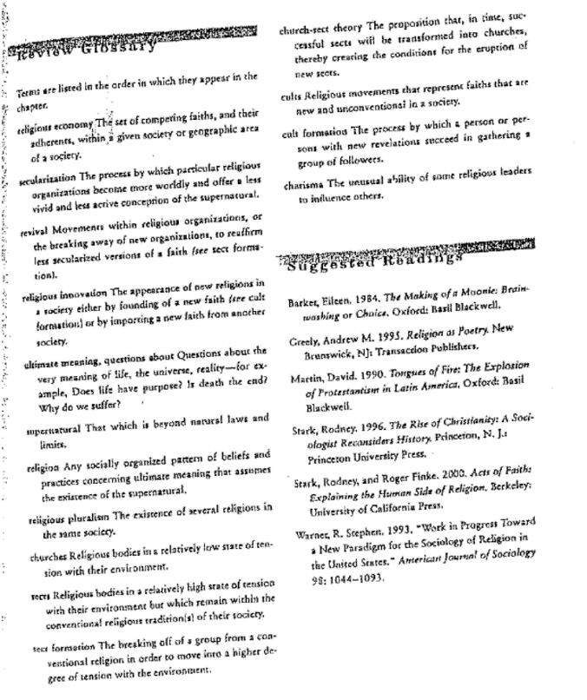

**Week 11 (27 OCT & 29 OCT)**

**Aging and the Elderly (TES)**

Macionis, John J. (2008) ‘Aging and the Elderly’ in Sociology. 12th edn. NJ:  Pearson.

As the country's elderly increases, age segregation will decline. Ageing is unpreventable yet is viewed as a negative thing. Rising living standards and advancing technology responsible for ageing population.

 Young old

* Between 65 and 75, typically living independently with good health and financial security; likely to live as couples.

Old Old

* Pass 75 and are more likely to have heath and financial problems, and are more dependent on others.

Hunting and gathering society will view elderly as economic burden as they do not have physical strength and stamina

Agrarian society- some individuals will accumulate considerable wealth over time, and those who are the eldest will then enjoy a form of social organisation in which elderly will have the most wealth, power and prestige. (gerontocracy)

Industrial and post-industrial societies- transform elders into elderly as the rapid changing of the knowledge and economy puts them at an disadvantage.

Erik Erikson's theory

Elderly people must resolve a tension of "integrity versus despair"

No matter how much they are learning and achieving, their life are nearing to an end.

Integrity means that life is assessed realistically, without which it may turn into a time of despair- a dead end with little positive meaning.

Caregivers

* informal and unpaid care provided to a dependent person by family members, other relatives or friends. Although parents provide caregiving to children, the term is often more applied to the needs of elderly people.
* This leads to elder abuse as the caregivers experience fatigue, emotional distress and guilt from not being able to do more.

Ageism can be obvious and straightforward as older people are discrimination and prejudiced over

* Negative stereotypes as being helpless, confused, unable to deal with changes, and generally unhappy.
* It is true sometimes but often generalised for the entire age group.

Functionalist

Elaine Cumming and William Henry - physical decline and death will disrupt society, which in response the society disengages the elderly by gradually transferring statuses and roles from the old to the young to prevent minimal disruption.

Symbolic interaction

High level of activity increases personal satisfaction in old age.

Job disengagement is not rejected but the elderly will be found new roles to replace those they leave behind.

Conflict theory

Middle aged people tend to enjoy the greatest power and the most opportunities and privileges, and the elderly and young people under the age of 25 have a higher risk of poverty.

Marxist: Steven Spitzer says that a profit-orientated society devalues any people that is less productive and as older people who do not work, the society labels them as wildly deviant

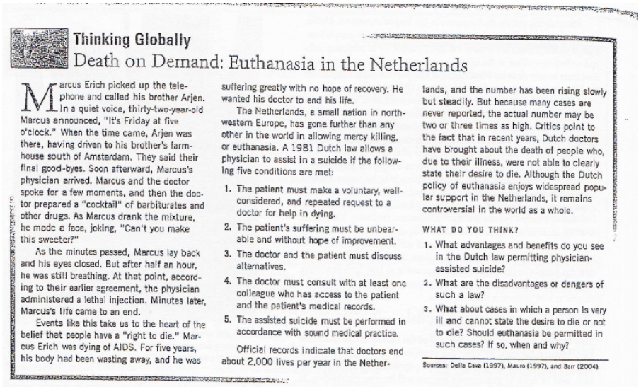

Riley, Matilda W. and Riley, John W. Jr. (1994) ‘Structural Lag: Past and Future’ in Matilda Riley and Anne Foner, eds., *Age and Structural Lag:  society’s failure to provide meaningful opportunities in work, family, and leisure.* NY: John Wiley.

Structural lag- changes in age structures lag behind changes in lives.

Numerous social norms and inflexible social structures, roles has lagged behind.

He proposed an "age-integrated" structure rather than an "age-segregated" structure.

Age-integrated moment allows work, play and education to occur simultaneously.

**Week 12 (3 & 5 NOV)**

**Deviance and Crime (KL)**

What is the relationship between crime and deviance, laws and moral sanctions?

Crime is a subset of deviance.

Deviances do not have to be morally sanctioned.

Deviances viewed differently in different countries; and different culture.

Deviance and culture are very interconnected.

How are power and deviance related?

Marginalisation as the power determines whether they are deviant or not.

Social institutions can also determine deviancy.

Moral panic: when there is a large group of people who recognises there is deviants which is threatening our social norms.

Media: moral gatekeeper

Moral gatekeepers can be parents; or spouses; cybercitizens.

Durkheim "today's deviance is tomorrow's morality"

* people are socialised to not be like deviants; and this creates moral standards.

Many deviants are revolutionary; which creates change and transformation.

Goffman, Erving (1959/2002) ‘The Moral Career of the Mental Patient.’ in Earl Rubington and Martin S. Weinberg (eds), *Deviance: The Interactionist Perspective*, 8th edn. Boston: Allyn and Bacon, 98-107.

Erving Goffman

* Mental patients has three main phrases; prepatient, inpatient, ex-patient
* Perception of losing one's mind is based on culturally derived and socially engrained stereotypes as to significance of symptoms such as hearing voices, losing temporal and spatial orientation and sensing one is being followed.

DeYoung, Mary (1998/2003) ‘Moral Panics: The Case of Satanic Day Care Centers.’ in Patricia Adler and Peter Adler (eds), *Constructions of Deviance: Social Power, Context, and Interaction*, 4thedn. Victoria: Wadsworth Thomson Learning, 160-168.

Moral panic

* was coined by Cohen to describe a collective response
* Generated by unsettling social strain and incited and spread by interest groups, toward persons who are actively transformed into "folk devils" and then treated as threats to dominant social interests and values.
* High emotional claims and fear-based appeals tend to lead to increased social control that typically follows from such consent to serve as a stabilizing function at a time of unsettling social strain.

Durkheim

* Refers to as normative contours and moral boundaries of a given society at any historical moment

Goode and Ben-Yehuda

* Moral panic is widespread, over-reactive, volatile, hostile, and largely irrational
* Basic analysis of any moral panic must account for its timing, target and trigger, content, spread and denouncement.

Case study: Satanic Day Care Centres

* Increasing participation of women in the workforce places more children into day care centres.
* Economic strains forces families to put their children into day care provides
* Media played a huge role in ensuring the spread of moral panic.
* Denouncement:

Extra Research:

[Michel Foucault](http://en.wikipedia.org/wiki/Michel_Foucault) believed that [torture](http://en.wikipedia.org/wiki/Torture) had been phased out from modern society due to the dispersion of power; there was no need any more for the wrath of the state on a deviant individual. Rather, the [modern state](http://en.wikipedia.org/wiki/Modernity#Sociologically) receives praise for its fairness and dispersion of power which, instead of controlling each individual, **controls the mass**.

He also theorized that institutions control people through the use of [discipline](http://en.wikipedia.org/wiki/Discipline).[[14]](http://en.wikipedia.org/wiki/Deviance_%28sociology%29#cite_note-Steiner.2C_Benjamin_2009-14)"Race and ethnicity could be relevant to an understanding of prison rule breaking if inmates bring their ecologically structured beliefs regarding legal authority, crime and deviance into the institutional environment." For example, the modern prison (more specifically the [panopticon](http://en.wikipedia.org/wiki/Panopticon)) is a template for these institutions because it controls its inmates by the perfect use of discipline.

Foucault theorizes that, in a sense, the [postmodern society](http://en.wikipedia.org/wiki/Post_modern#History_of_term) is characterized by the lack of [free will](http://en.wikipedia.org/wiki/Free_will) on the part of individuals. Institutions of knowledge, norms, and values, are simply in place to categorize and control humans.

From <[http://en.wikipedia.org/wiki/Deviance_(sociology)#Karl_Marx](http://en.wikipedia.org/wiki/Deviance_%28sociology%29#Karl_Marx)>